Strategic Management-Macy’s, Inc.
Student Name:
Institutional Affiliation:
Date:

Company Background
Macy’s, Inc. is one of the nation’s premier retailers. With 2017 fiscal sales of $24.837 billion and approximately 130,000 employees, the company operates more than 690 department stores under the nameplates Macy's and Bloomingdale's, and approximately 160 speciality stores that include Bloomingdale's The Outlet, Bluemercury and Macy’s Backstage. Macy’s, Inc. operates stores in 44 states, the District of Columbia, Guam and Puerto Rico, as well as macys.com, bloomingdales.com and bluemercury.com. Bloomingdale’s stores in Dubai and Kuwait are operated by Al Tayer Group LLC under license agreements. Macy's, Inc. has corporate offices in Cincinnati, Ohio and New York, New York. Before June 1, 2007, Macy's, Inc. was known as Federated Department Stores, Inc. The company's shares are traded under the symbol "M" on the New York Stock Exchange (Macy’s, Inc., 2018).
Company History
Macy’s started as small, fancy dry goods store that opened on the corner of 14th Street and 6th Avenue in New York City in 1858. After several failed retail ventures, Rowland Hussey Macy at the age of 36 with the launched R.H. Macy & Co. He adopted a red star as his symbol of success, dating back to his days as a sailor. First-day sales totalled $11.06, but by the end of the first full year, sales grossed approximately $85,000. By 1877, R.H. Macy & Co. had become a full-fledged department store occupying the ground space of 11 adjacent buildings. Macy's is known for several firsts that changed the retail industry (Macy’s, Inc., 2018). It was the first retailer to promote a woman, Margaret Getchell, to an executive position, making business history. Macy’s pioneered such revolutionary business practices as the one-price system, in which the same item was sold to every customer at one price, and quoting specific prices for goods in newspaper advertising. They were the first to introduce such products as the Idaho baked potato and coloured bath towels.
Macy’s also was the first retailer to hold a New York City liquor license. By November of 1902, the store had outgrown its modest storefront and moved uptown to its present Herald Square location on Broadway and 34th Street, establishing an attraction for shoppers from around the world. With the store’s 7th Avenue expansion completed in 1924, Macy’s Herald Square became the “World’s Largest Store,” with more than 1 million square feet of retail space. Note that Macy’s Herald Square expanded to 1.1 million square feet of retail space in the renovation project unveiled in 2015. By 1918, R.H. Macy & Co. was generating $36 million in annual sales (Macy’s, Inc., 2018). The company went public in 1922 and began to open regional stores and take over competing retailers. In 1923, the Toledo-based department store Lasalle & Koch was acquired; the next year, Davison-Paxton in Atlanta was acquired; and in 1936, the Newark-based Bamberger's was purchased. To help celebrate their new American heritage, Macy's immigrant employees organized the first Christmas Parade in 1924. The procession featured floats, bands, animals from the zoo and 10,000 onlookers, beginning a time-honoured tradition now known as the annual Macy's Thanksgiving Day Parade.
In 1945, the company expanded west and purchased O’Connor Moffatt & Company in San Francisco. Two years later, O’Connor Moffatt stores, including the landmark Union Square store that opened in 1866, were converted to Macy’s. Macy’s California broke new ground with the first department store flower show in 1946. What began as a fragrance promotion in the cosmetics department now annually welcomes the spring season, treating visitors to a botanical, cultural and community spectacle and is held in New York City, Chicago, Minneapolis, Philadelphia and Washington, D.C., in addition to San Francisco. In 1971, Macy’s Union Square store’s lower level, once cluttered with bargains, was transformed into “The Cellar,” changing the way customers shop for housewares. Due to its success, the Herald Square store followed suit five years later (Macy’s, Inc., 2018).
On December 19, 1994, Federated Department Stores, Inc. (now known as Macy's, Inc.) acquired R.H. Macy & Co., creating the world's largest premier department store company. Federated Department Stores operated more than 400 department stores and 157 speciality stores in 37 states. A&S Department Stores were converted to the Macy's nameplate in May 1995. Also in 1995, Federated acquired The Broadway Department Stores, bringing Broadway, Emporium and Weinstocks to the Macy's family, as well as six former I. Magnin stores. Some 46 stores were converted to the Macy’s nameplate (Macy’s, Inc., 2018). Following the model of A&S, Jordan Marsh Department Stores of Boston, already owned by Federated, was converted to Macy’s in March 1996. In January 2001, Macy’s absorbed 17 Stern’s Department Stores located in New York and New Jersey. In June 2001, Federated purchased the Liberty House operations in Hawaii and Guam, bringing the proud Macy’s tradition and heritage to the Pacific.
Macy’s entered 2005 with about 240 locations, primarily on the East and West Coasts. With the conversion of all Federated’s regional store name-plates in March 2005, Macy’s grew to about 425 locations across the country (Macy’s, Inc., 2018). In September 2006, with the conversion of stores acquired from The May Department Stores Company, Macy’s served customers through approximately 730 stores. As of April 1, 2017, Macy's now serves customers through approximately 670 stores in virtually every major geographic market in the United States, as well as the macys.com website.
Macy’s, Inc. Strategy
Corporate Vision
Macy’s, Inc. is a premier Omni-channel retailer with iconic brands that serve customers through outstanding stores, dynamic online sites and mobile apps. Both Macy’s and Bloomingdale’s are known worldwide, and each has its own unique identity and customer focus. Bluemercury is widely recognized as the nation’s largest and fastest-growing luxury beauty products and spa retail chain. Macy’s, Inc. clearly recognizes that the customer is paramount and that all its actions and Omni-channel strategies must be directed toward providing a personalized merchandise offering and shopping experience online and in-store (Su et., nd).
Aggressive implementation of the company’s customer-centric strategies by a talented, experienced organization provides Macy’s, Inc. with an important competitive edge.
At Macy’s, Inc., our greatest strength lies in the expertise, judgment and talent of our people. Every day a production of enormous magnitude takes place on our selling floors and behind the scenes, where our people bring the company’s strategic goals to life. Our priority of attracting, retaining and developing the most talented people in the retail industry has been and will continue to be our greatest advantage (Macy’s, Inc., 2018).
Corporate Financial Objectives
The financial objectives of Macy’s, Inc. are:
● To grow sales profitably;
● To maintain a profitability rate that is among best-in-class retailers, as measured by Adjusted EBITDA as a percentage of net sales;
● To improve return on invested capital; and
● To maximize total shareholder return.

North Star Strategy

R.H. Macy chose the star as our company symbol when he first founded the business more than 150 years ago. It was derived from a red star tattoo on his forearm from his sailing days, and inspired by the North Star. The five points of the North Star Strategy are:
- From Familiar to Favorite: includes everything we do to dial our brand to full bright at all touch points. Consumer research confirms the Macy's brand is well-known and well-loved throughout the country and growing across the world. Actions at this point include understanding and anticipating our customers' needs and strengthening our fashion authority, as well as executing initiatives around our loyalty and pricing strategies.
- It Must Be Macy’s: is all about delivering the products and experiences our customers love and can only find with us. This includes styles and home fashion for every day and special occasions, from our leading private brands, as well as exclusive national brands or assortments found only at Macy’s. It celebrates our iconic events. This point also encompasses our strategies to appeal to more value-oriented customers in Macy’s Backstage and Last Act (Pivotal Resources, 2017).
- Every Experience Matters in-store and online: Our competitive advantage is the ability to combine the human touch in our physical stores with cutting-edge technology. We are enhancing our customers' experience as they explore our assortments, find their favourite styles, sizes and colours, and receive their purchase through the shopping channels they prefer. Our mobile app and digital capabilities complement the store experience and help our talented sales associates serve our customers better than ever. Macy’s app powers personalized recommendations, serves as a loyalty tool to deepen our customer relationships, and offers a simplified product discovery and checkout process. Our successful Buy Online Pickup in Store (BOPS) option will continue to provide customers with the Omni-channel shopping experience they love.
- Funding our Future: represents the decisions and actions we take to create resources to fuel our growth. We are focused on cost reduction and reinvestment, and creating value from our real estate portfolio.
- What’s New, What’s Next: explores how we innovate to turn consumer and technology trends to our advantage and drive growth. This includes exploring previously unmet customer needs and making smart investment decisions based on customer insight and analytics. We’ll use these insights to improve our digital concepts, brand partnerships and acquisitions, while also innovating our internal processes and customer-facing ideas (Pivotal Resources, 2017).
External Environment Analysis

Internal Environment Analysis
Macy’s internal context is substantial and incredibly varied, from having one of the largest workforces in the U.S, to once being known as the leader of innovation, redesigning teen culture and always aiming for that top tier in management. Macy’s workforce is vast and innovative, offering an average of 166,000 jobs per year from 2010-2016, 75% being women and 65% being managers as well. Macy's core competencies include managing capabilities, their relation to their suppliers, human capital as well as their marketing strategy. Even though for a good time this all worked for Macy's their operating systems and processes didn't catch up with the world around them. In this year 2018 Macy's has had to close 11 stores, and their profit has dropping year to year, this year dropping 13%. Table 1 (as in the appendix) illustrates Macy's recent struggle to remain a competitive company ((Macy’s, Inc., 2018).
From the said Table, it is evident that financially, Macy’s is not performing as it was once was and I don’t see it getting any better. With how competition is in today’s day an age and how technology has advanced so drastically I don’t see how Macy’s financial health can withstand. The only way they can save this dip the company is facing is to make a new strategy and focus on what they need to advance. If they change their strategy and it works they might come back on top if not, it doesn’t seem to pretty (UKEssays, 2015).
Industry Analysis
Macy's does not seem to be in a very good position when it's up against its competitors. According to CSIMarket, Quarter 3 of 2017, Macy's Inc. reported a total revenue decrease of 6.13% while its competitors reported increases of about 14.59%.Also with a reported net margin of 0.64%. , Macy’s profitability was lower than its competitors (Jones, 2017) (See Figure 2 and 3 in the Appendix).
The level of competition among the existing competitors in the industry is very stiff. Despite their not so great reporting at the end of Quarter 3 of 2017, Macy’s is ranked as one of the top three companies in this Industry (Jones, 2017). The growth rate of the market as a whole is pretty low. This means these companies have to compete with each other in price, quality and services offered to customers. Many department stores offer the same products for similar or less price. Macy’s is one of the companies that offer higher quality for a higher price (As illustrated in Figure 4 in the appendix).
Competitive Advantage
According to CSIMarket, Macy’s seeks to attract customers by offering superior selections, obvious value, and distinctive marketing in stores that are located in premier locations, and by providing an exciting shopping environment and superior service through an Omni channel experience. Macy’s competitive strategy is to be able to charge much higher prices by providing better products or service through Industry-wide differentiation.
One advantage that Macy’s possess is the execution of their core strategies. There are three core strategies that Macy’s incorporate to help with their efforts to become an international retailing brand and continue to successful compete within the industry. These core strategies are known as Macy's localization, Omni channel integration and Magic Selling (Sluzewski & Stautberg, 2016).
Macy's localization allows them to tailor the assortment of merchandise and shopping experience to each customer based on their location by being attentive to climate zones. Through Omni channel integration, Macy's can keep up with new technology which contributes to keeping customer's happy. Macy's is now able to cater to customers that enjoy online shopping. They have even incorporated a system where customers can buy online and then pick it up at their local store on the same day (Macy’s, Inc., 2018). Mobile point-of-sale devices, kiosks and tablets help employees to provide quick and effective customer service. Macy's has also developed a training schedule for all employees to improve their "Magic selling skills" which helps them to have a better understanding of their customers.
Another key advantage of Macy’s competitive advantage is the recreation of their physical store footprints. Macy’s has had the advantage of operating in the most attractive retailing locations in America. Businesswise states that, while still maintaining a significant bricks-and-mortar presence in 49 of the top 50 U.S (CSIMarket, 2017). Markets, Macy’s will operate fewer stores and concentrate its financial resources and talent on our better-performing locations to elevate their status as preferred shopping destinations. These two key advantages can prove to have a sustainable advantage and resulting performance. Macy’s has kept up with technology, re-created the in-store experience and continued to offer higher quality products so that they can retain their current customer’s and attract new ones.

References
CSIMarket. (2017). Macy's, Inc Comparisons to Its Competitors, Market Share and Competitiveness by Segment. Retrieved from https://csimarket.com/stocks/compet_glance.php?code=M
Jones, C. (2017, May 11). Macy's shares fall 17% in unexpected profit plunge. USA TODAY. https://www.usatoday.com/story/money/2017/05/11/macys-sales-profit-plunge-and-so-does-shares-price/101543670/
Macy’s, Inc. (2018). About Us. Retrieved from https://www.macysinc.com/about-us/
Macy’s, Inc. (2018). Company History. Retrieved from https://www.macysinc.com/about-us/macysinc-history/overview/default.aspx
Macy’s, Inc. (2018). Press Release. Retrieved from http://investors.macysinc.com/phoenix.zhtml?c=84477&p=irol-newsArticle&ID=2324867
Macy's, Inc. (2018). Macy's North Star Strategy. Retrieved from http://macysinc.com/macys/north-star-strategy/default.aspx
Pivotal Resources. (2017). Client Story: Macy’s. Retrieved from https://www.pivotalresources.com/macys-success-story/
Sluzewski , J. & Stautberg, M. (2016, August 11). “Macy's, Inc. Outlines Moves to Drive Profitable Growth and Enhance Shareholder Value.” Business Wire. Retrieved from www.businesswire.com/news/home/20160811005502/en/Macy%E2%80%99s-Outlines-Moves-Drive-Profitable-Growth-Enhance.
Su, J., Hernandez, M., Yuan, T. & Xiangze, X. (nd). “Team4, Macy's.” Business Strategy. http://team4macys.blogspot.co.ke/p/business-strategy.html
UKEssays. (2015). General Environment Analysis of Macy's, Inc. Retrieved from https://www.ukessays.com/essays/marketing/general-environment-analysis-of-macys-inc-marketing-essay.php

Appendix
Table 1
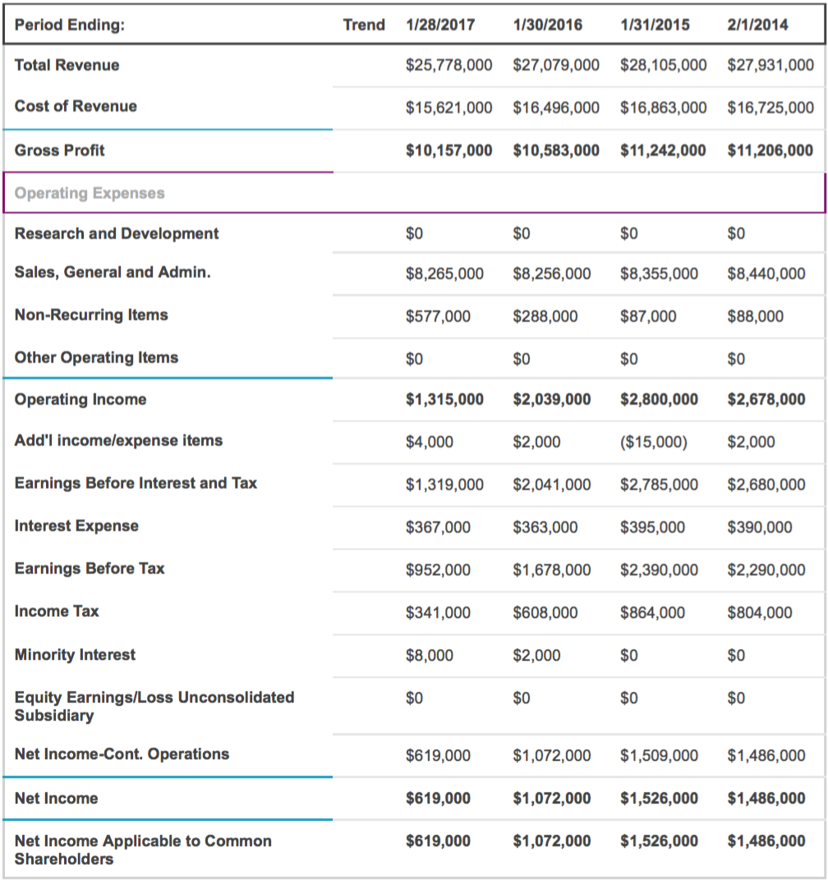

Figure 2

Figure 3

Figure 4
MACY’S
DILLARDS
KHOLS
BURLINGTON
PRODUCT QUALITY

ROSS
LOW
RETAIL PRICING
HIGH
LOW

